Assignment #1(LO 1)

Name: Eva Nazira binti Nazry Syah

Matric No:1917904

1. By using google colab code to access your webcam, capture three different facial  
   expressions of yourself.

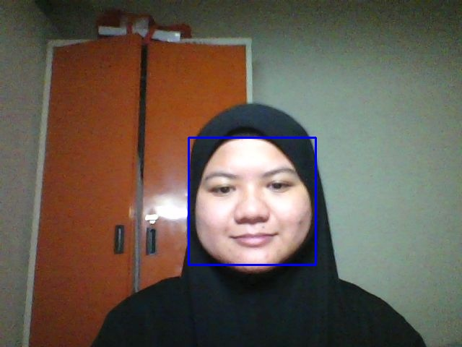

Figure 1: Normal

Figure 2: Angry

Figure 3: Happy

1. Apply both Canny Edge Detection and Sobel Edge Detection to only the face area of the image using a suitable threshold values.

1. Perform blurring of only faces in those images. (5 Marks)

1. Calculating the number of coins in an image using contours. (5 Marks)